SIMATS ENGINEERING
ASSESSMENT TOOL 2

COURSE NAME: Ethical Hacking
COURSE CODE: ITA1409

COURSE OUTCOME COVERED
CO2: Execute footprinting in social engineering such as DNS analysis, competitive intelligence gathering, and attack simulations to collect relevant information for identifying potential security.

Code of Conduct:
I Palle Amrutha(192372359) certify that this submission is my original work and that I have adhered to the guidelines specified for this assessment.I understand that any violation of academic integrity rules will result in disciplinary action.
Signature of the student: P.Amrutha

Question 1: OSINT Email Enumeration Assessment using theHarvester

Objective
To gather publicly available information related to tesla.com using theHarvester and analyze how attackers could use the information during reconnaissance.
Tool Used
• Kali Linux

• theHarvester

Commands Executed
theHarvester -d tesla.com -b crtsh theHarvester -d tesla.com -b yahoo theHarvester -d tesla.com -b subdomaincenter

Screenshots
Insert screenshots of:
- theHarvester execution

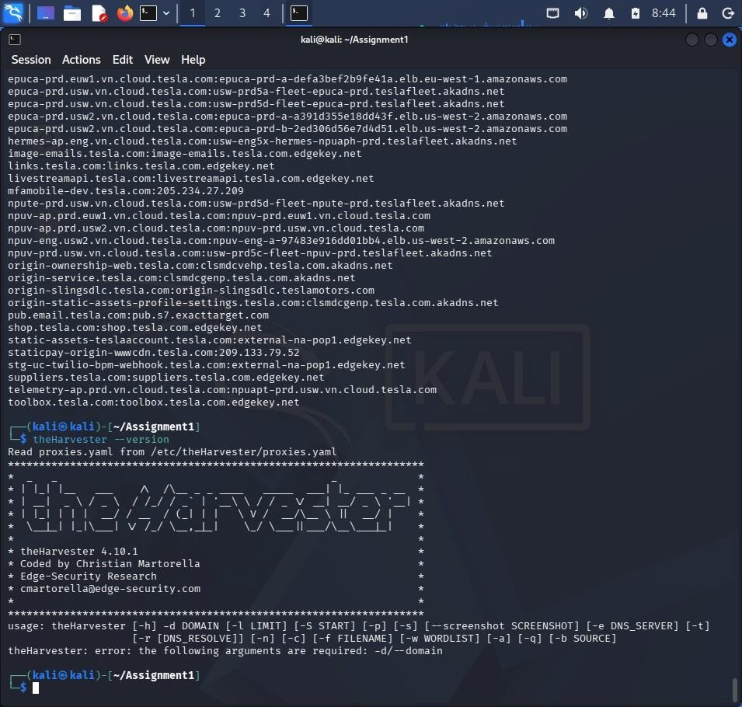

- Subdomains discovered

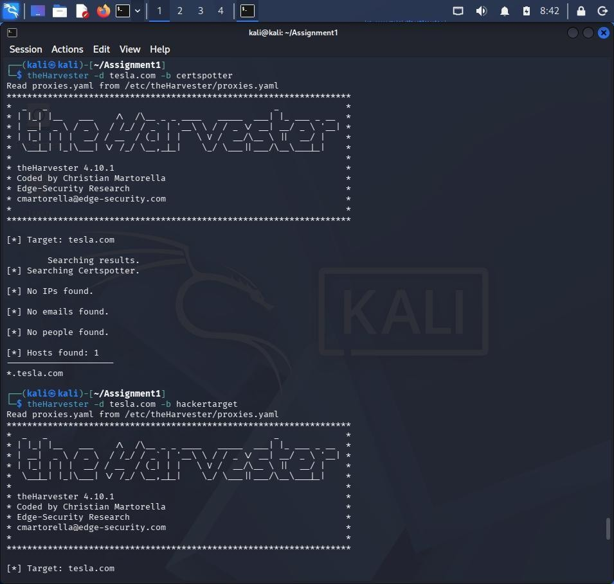

- Hosts/IPs discovered

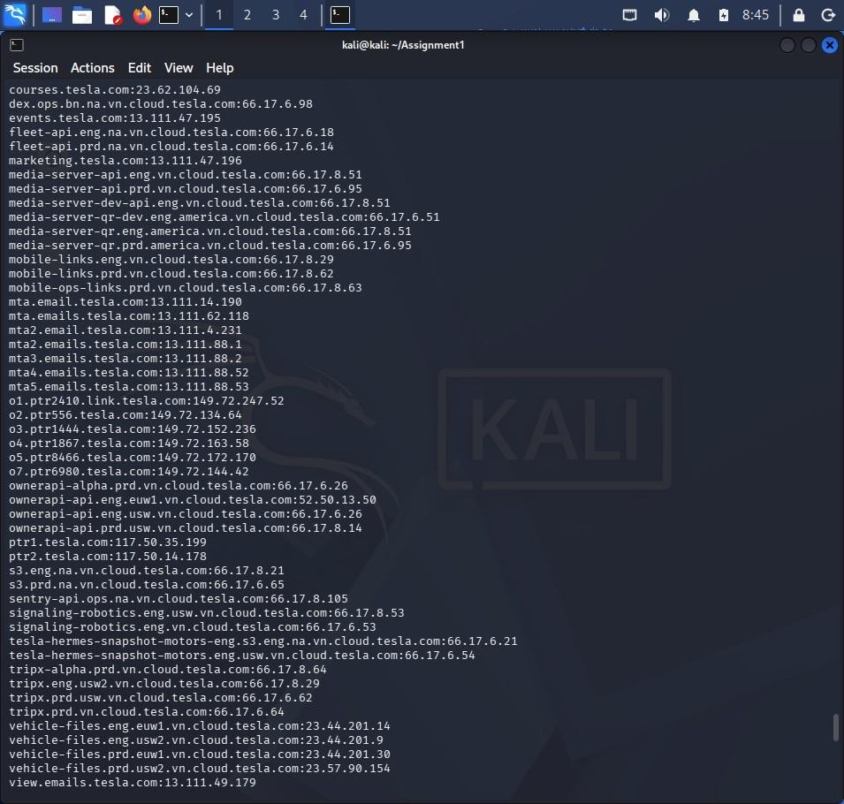
Findings

Subdomains
Create a table using the results you obtained.

Subdomain | IP Address
mta.email.tesla.com | 13.x.x.x
view.email.tesla.com | 13.x.x.x
ptr1.tesla.com | 117.x.x.x
(Add more from your results.)

Email Addresses
If no emails were found:
No public email addresses were discovered during enumeration.
Hosts and IP Addresses
Include the hostnames and IPs you collected.

Categorization of Email Roles
Example:

Role | Example Email
Support | support@company.com
Sales | sales@company.com
HR | hr@company.com
Administration | admin@company.com
Technical Team | tech@company.com
If none were found, write:
No email addresses were discovered; therefore role categorization could not be performed.

Risk Analysis

Spear-Phishing
Attackers can use discovered domains and hostnames to create convincing phishing emails.
Credential Harvesting
Fake login portals can be created using discovered organizational information.

Impersonation Attacks
Attackers may impersonate internal departments.

Countermeasures
- Limit public exposure of employee email addresses.
- Use privacy protection for DNS records.
- Conduct security awareness training.
- Implement SPF, DKIM, and DMARC.
- Use Multi-Factor Authentication (MFA).
- Monitor information leakage.

Conclusion
OSINT can reveal valuable organizational information that attackers can leverage during reconnaissance.

Question 2: Phishing Awareness Simulation using GoPhish
Objective
To simulate a phishing campaign and measure user awareness.

Tool Used
- GoPhish
- Kali Linux
Campaign Setup

User Group
Dummy Employees

Name | Email
John Doe | john@testlab.local
Jane Smith | jane@testlab.local
David Kumar | david@testlab.local
Sarah Lee | sarah@testlab.local

Email Template
Subject:
Action Required: Password Reset
Landing Page
Password Reset Portal

Screenshots
Insert screenshots of:
- GoPhish Dashboard
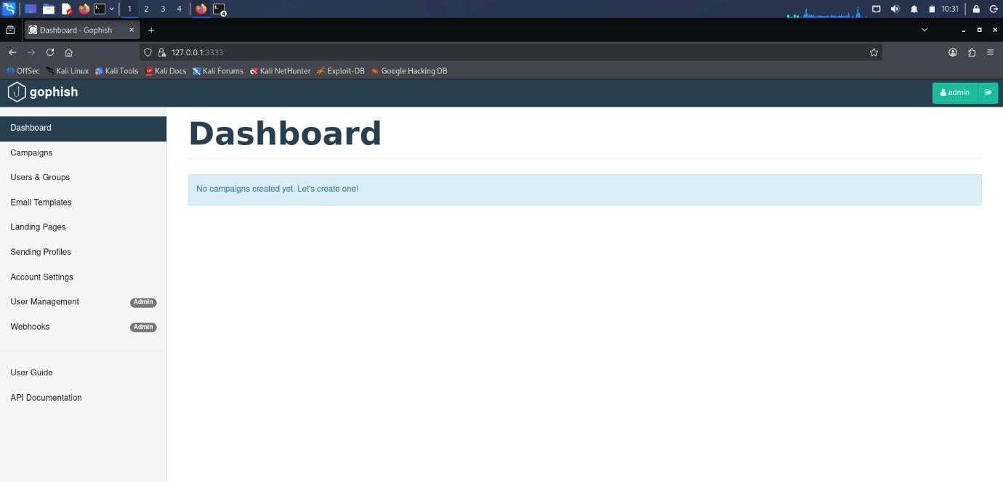

2.User Group Creation

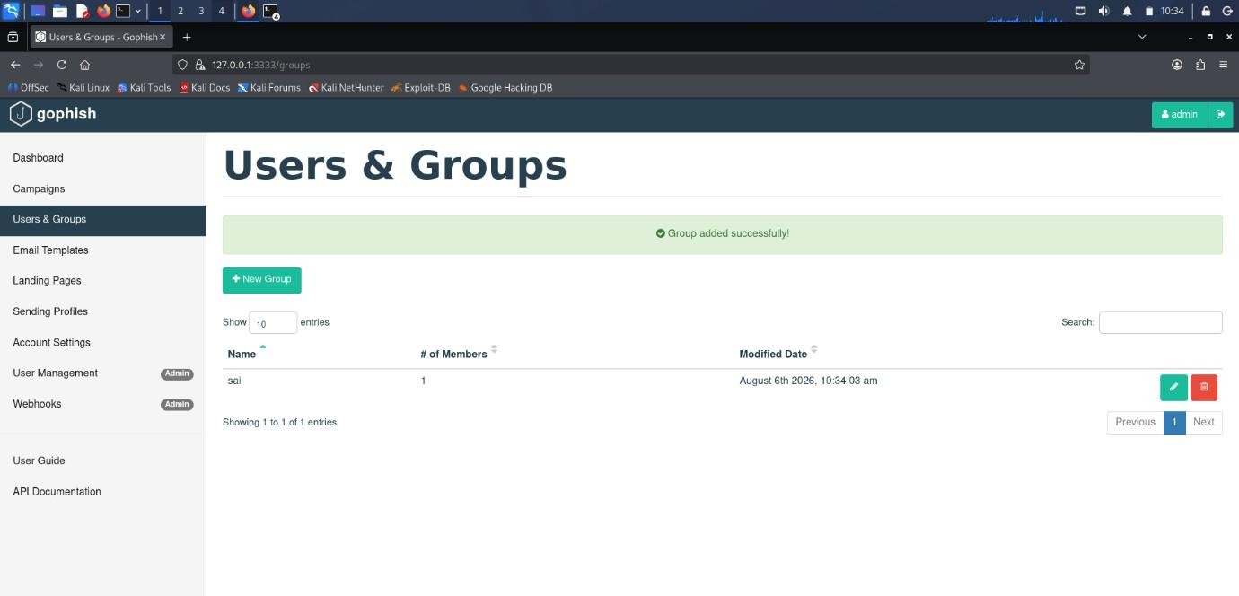

3.Email Template Creation
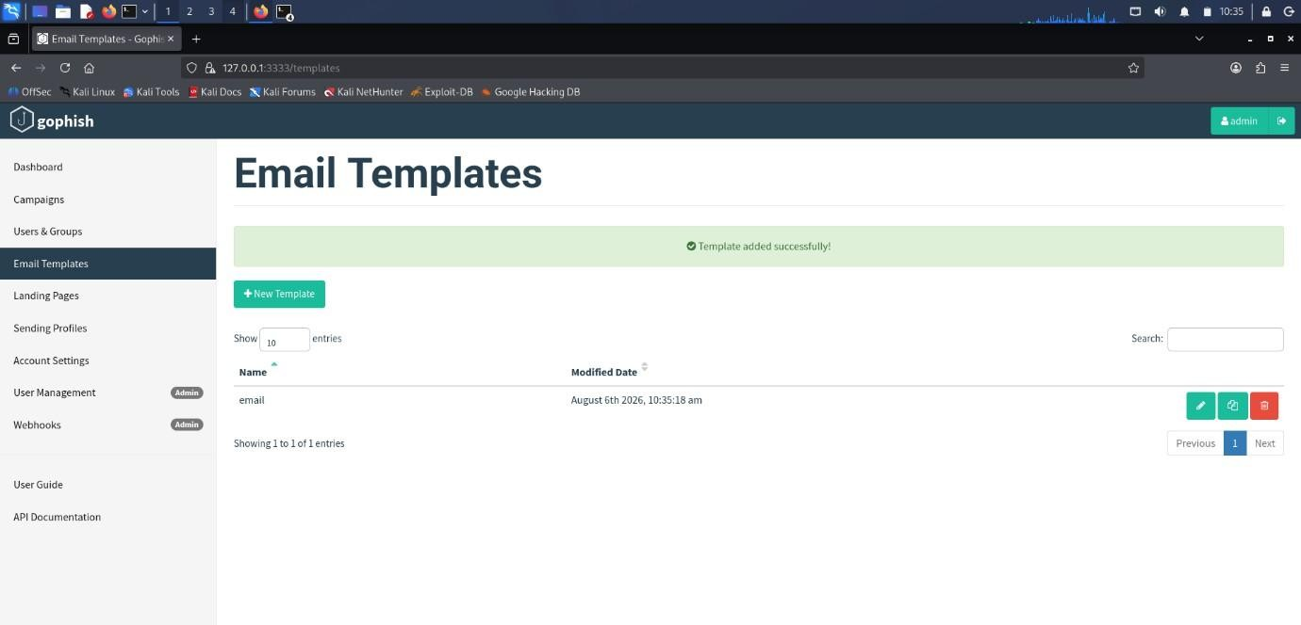

- Landing Page Creation

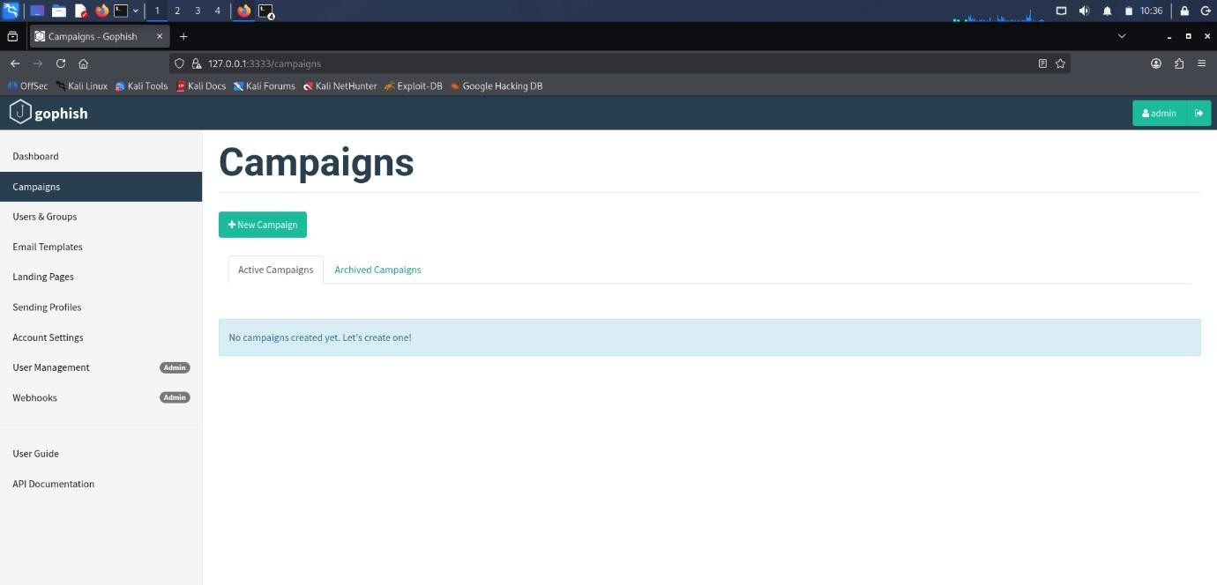
Campaign Results
Use the values shown in your dashboard.

Campaign Results Table

Metric | Value
Total Emails Sent | 4
Successfully Delivered | 4
Emails Opened | 3
Links Clicked | 2
Credentials Submitted | 1

Delivery Rate
Formula:
(Delivered / Sent) × 100

Open Rate
(Opened / Sent) × 100 Click Rate
(Clicked / Sent) × 100

Recommendations
- Conduct regular phishing awareness training.
- Verify sender identities.
- Enable MFA.
- Avoid clicking unknown links.
- Report suspicious emails immediately.
- Deploy email security controls.

Conclusion
The phishing simulation highlighted user susceptibility to phishing attacks and the need for ongoing awareness programs.

Question 3: Nmap Aggressive Scan Assessment

Objective
To gather information about scanme.nmap.org using Nmap Aggressive Scan and analyze social engineering risks.
Tool Used
- Nmap
- Kali Linux Command Executed
nmap -A scanme.nmap.org
Findings

Open Ports
Port | Service
22 | SSH
80 | HTTP
9929 | NPING Echo
31337 | Elite

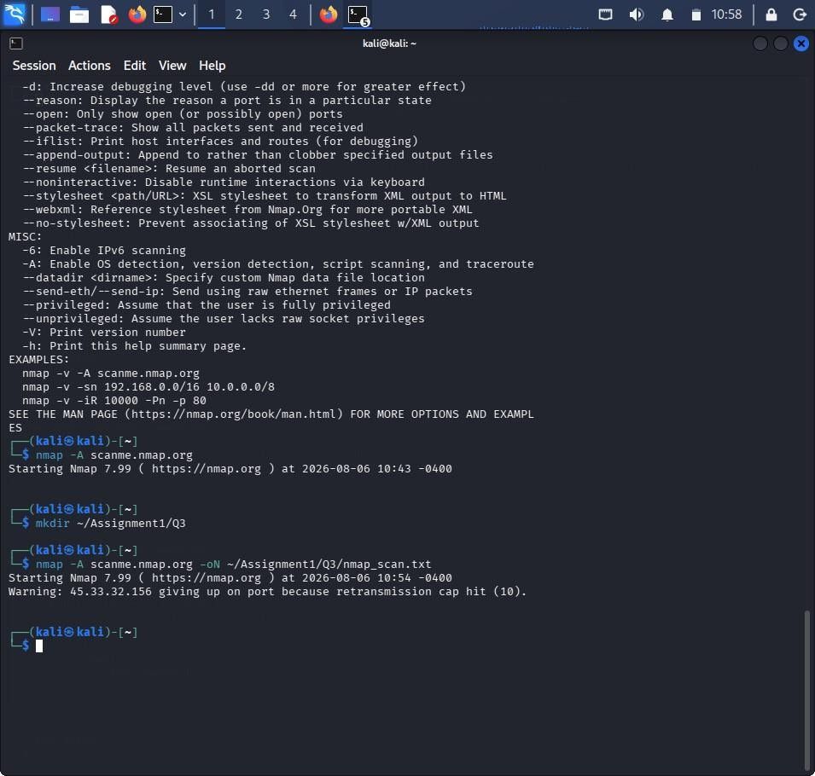
Service Versions
List detected versions from your scan.
Operating System
Linux-based operating system (or whatever Nmap reported).
Attack Methodology
Reconnaissance
Gather service and OS information.

Social Engineering
Create phishing emails pretending to be IT Support.
Example Subject:
Critical SSH Service Upgrade Required
Objective
Steal administrator credentials through a fake login page.

Defensive Recommendations
- Minimize service banner exposure.
- Apply security patches regularly.
- Enable MFA.
- Restrict administrative access.
- Conduct awareness training.
- Monitor suspicious activity.

Conclusion
Nmap revealed system information that could help attackers craft targeted social engineering attacks.

